**Installing NGINX Server – Assignment**

**Process:**

**Set Up AWS Resources**

Logged in to AWS Management Console.  
• Launched EC2 Instance: (virtual machine - Ubuntu).

And security groups to allowed SSH (port 22) traffic with instance type - T2.medium and 15Gb disk size and created PPK file.

**Connect to Your EC2 Instance**

•    Used SSH to connect to EC2 instance using the PPK file via Putty as below.

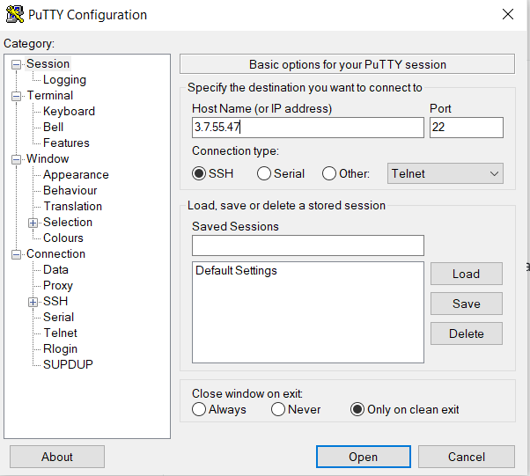

**Attached IAM role- Full admin access to the machine**

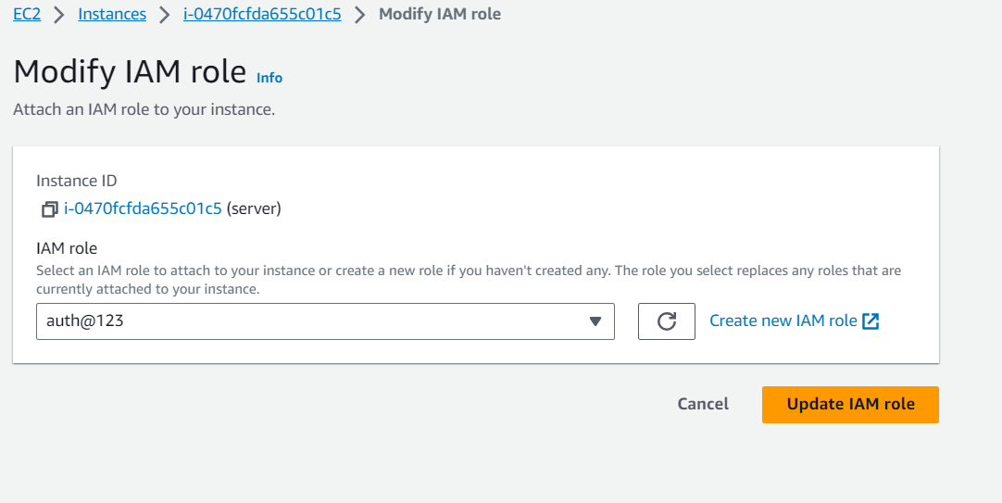

**Logged in to the machine using Putty as below:**

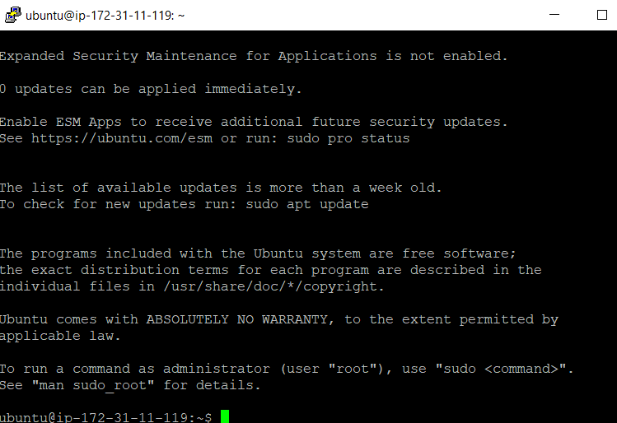

**Installed Ansible on to the machine as below:**

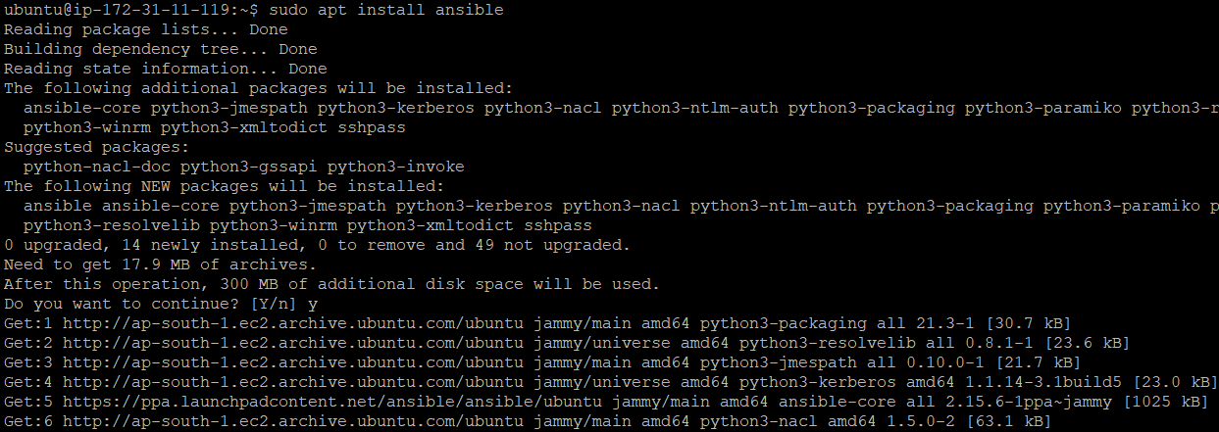



**After installing Ansible on to the machine done changes in to the /etc/ansible/hosts -Added host entry and private key in to the hosts file(Inventory File)**

**As below:**

[nginxservers]

3.7.55.47 ansible_user=ubuntu ansible_ssh_private_key_file=/home/ubuntu/fec.pem



**Now checked host is connected or not by using ping command as below:** ansible all -m ping

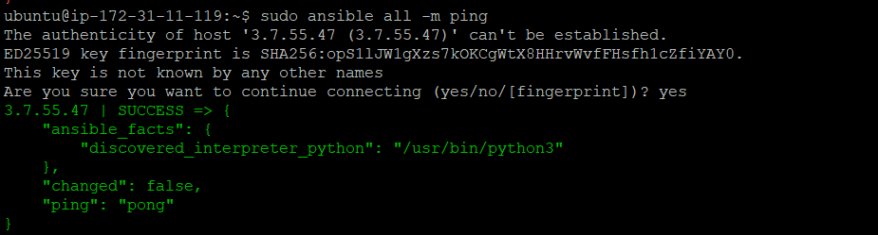

**After establishing a connection created ansible playbook file and ran it.**

**Playbookfile:**

- hosts: nginxservers

become: yes

tasks:

- name: update

apt: update_cache=yes

- name: Install Nginx

apt: name=nginx state=latest

notify:

- restart nginx

handlers:

- name: restart nginx

service: name=nginx state=reloaded

**Executed Playbook file using below command:**

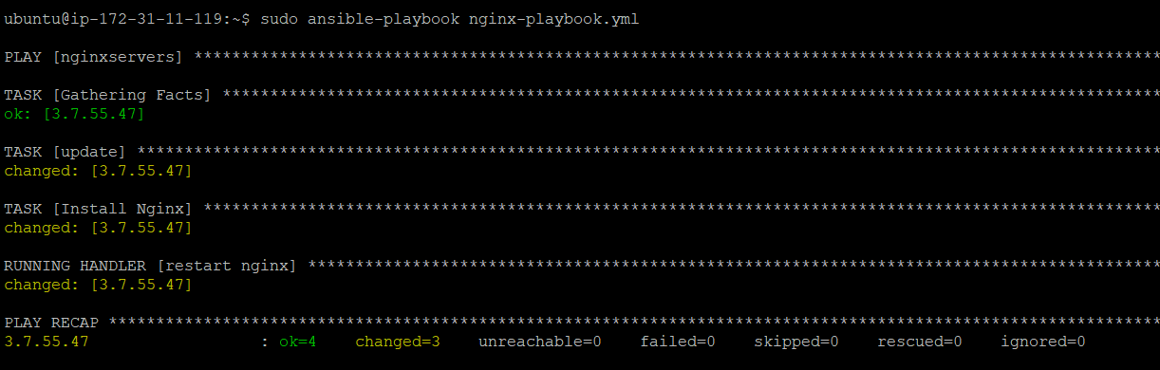

**Added port 80 to the machine for access to Nginx server.**

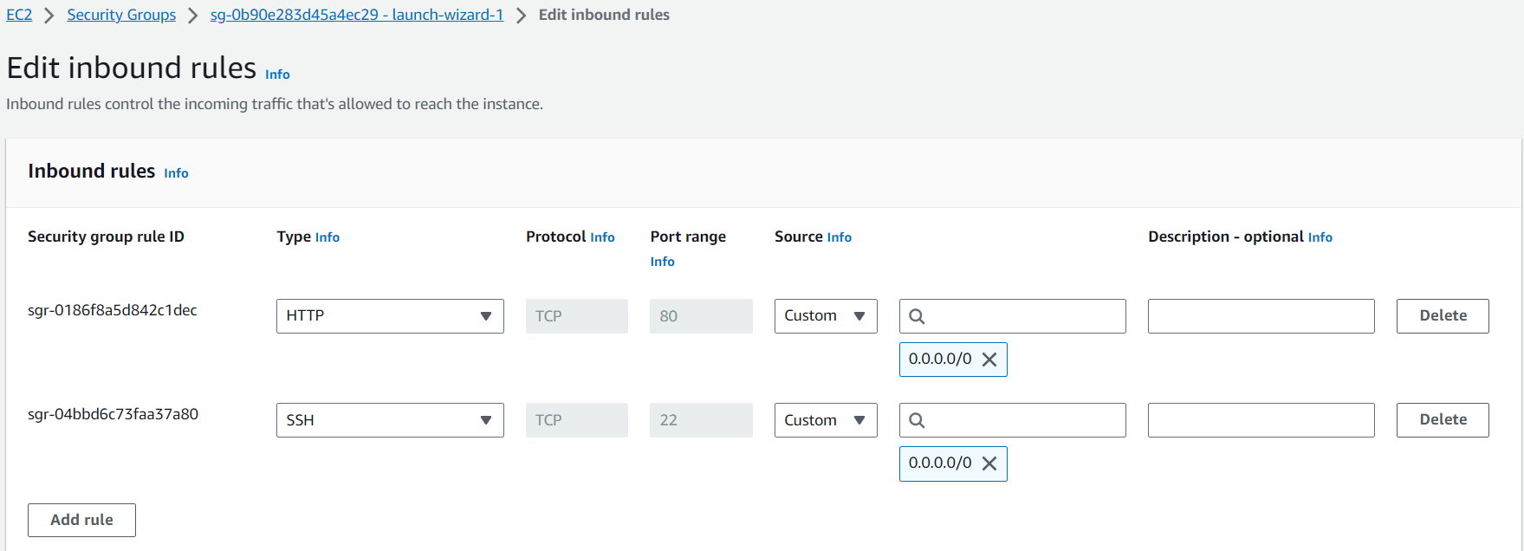

**And by hit public ip to the browser we got below result :**

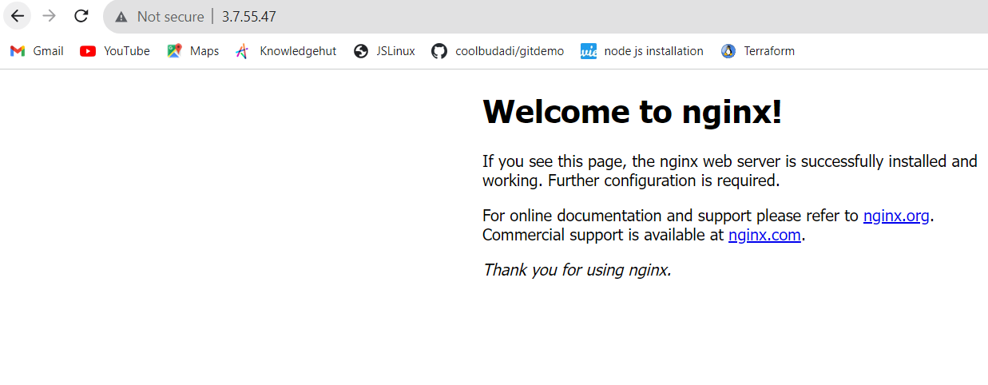

**Now need to install nginx server on to container so first installed docker on to machine as below:**

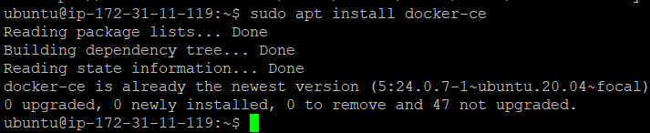

**Docker ps command for checking status of running container.**



**Created and run 3 containers under the machine**

1. **Ansible master**
2. **Target 1 container**
3. **Target 2 container**

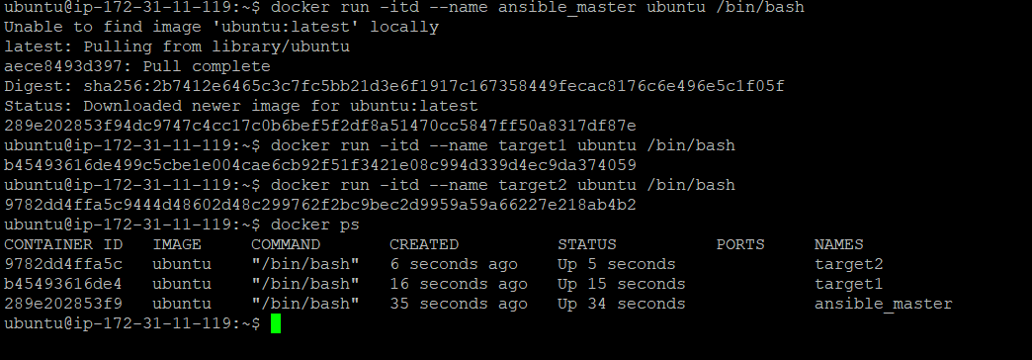

**Entered to the containers and installed required packages on to**

**All the containers as below: Installed =** python3 ansible vim iputils-ping openssh-cli



**Command for installation:**

Sudo apt install python3 ansible vim iputils-ping openssh-client -y

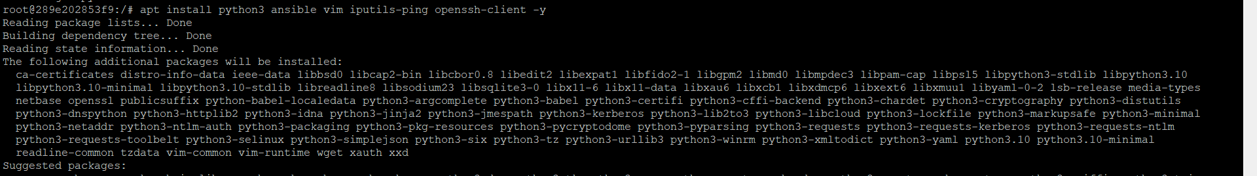

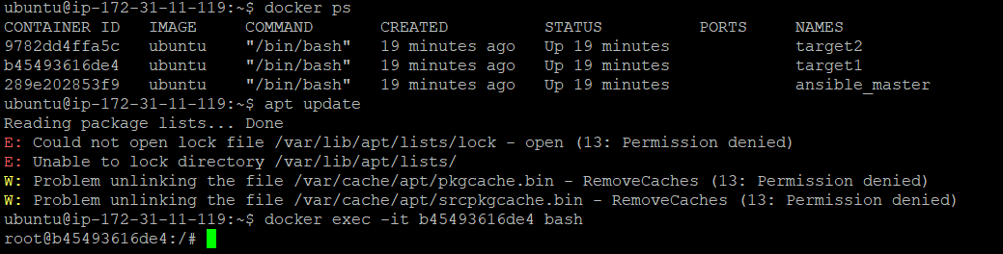

**Added Hosts entries to the inventory file(ansible master)**

"IPAddress": "172.17.0.3", ip of target 1 b45493616de4

"IPAddress": "172.17.0.4", ip of target 2 9782dd4ffa5c

**Now checked hosts are connected or not by using ping in ansible_master container command as below**



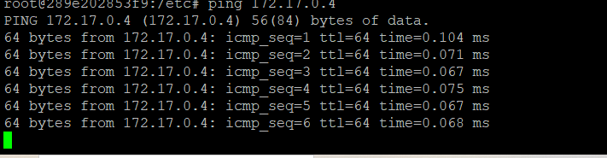

**After establishing a connection written playbook file for the same and ran it:**

**Playbook file :**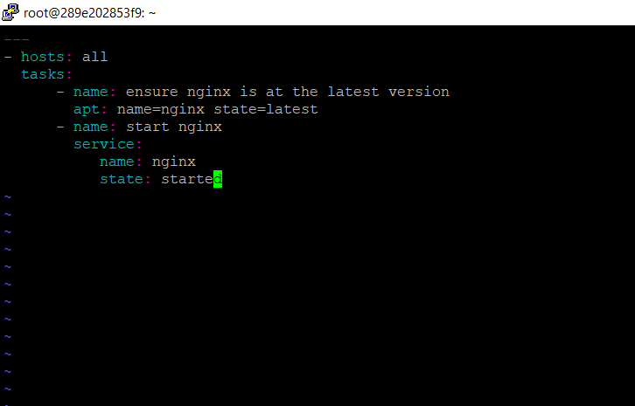

**And by using below command :**

Sudo ansible-playbook ng.yml

**We got successful result and installed Nginx server using ansible automation as below.**

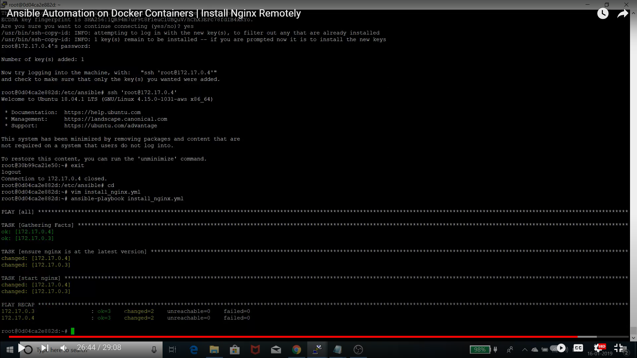

**Final Result:**

